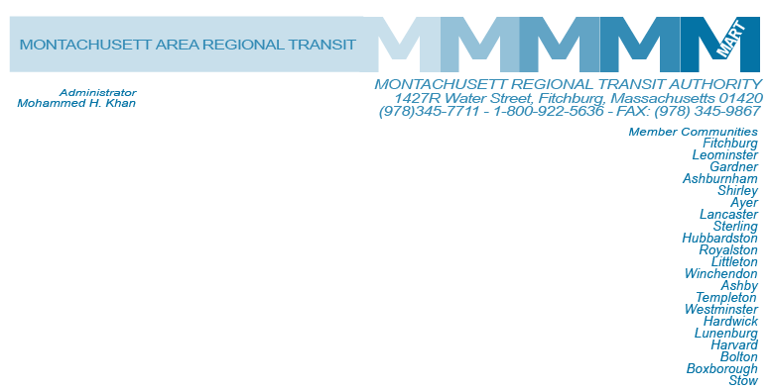

Posted 04/24/2014 at 9:33 am by JAV

MEETING OF THE MART Finance/Executive Compensation COmmittee

**MART Maintenance Facility**

**1427R Water Street**

**Fitchburg, MA 01420**

**Monday, April 28, 2014**

**10:00 A.M.**

### Agenda

* Administrator’s Financial Staffing Plan

-Telephone Discussion with Auditor and MART Senior Staff

-FY14 Audit Requirements by Auditor and Staff Assignment

* Other Business

Adjournment

C: City and Town Clerks: Please post this notice pursuant to MA General Laws Chapter 30A,

Sections 18-25.